Title of the Paper

# Name of Author 1, Author's Affiliation

# (Leave this out of the review versions of the paper)

# Name of Author 2, Author's Affiliation

# (Leave this out of the review versions of the paper)

**[…]**

Abstract

300 word abstract outlining the main features of the research suitable to be included in the conference abstracts book as guidance to delegates when choosing which presentations to attend.

Keyword 1; Keyword 2; Keyword3; … (up to 5)

Introduction in **Normal Style with noheading** and one paragraph space after Keywords.

Lorem ipsum dolor sit amet, consectetuer adipiscing elit. Aliquam lacus nulla, pulvinar a, mattis ut, consequat sodales.

Eksig_Heading1

4000-5000 word text in Normal Style (11pt Arial with 6pt spacing after paragraphs). Lorem ipsum dolor sit amet, consectetuer adipiscing elit. Aliquam lacus nulla, pulvinar a, mattis ut, consequat sodales, elit. Ut elementum justo ut urna. Pellentesque volutpat, urna et fermentum.  
  
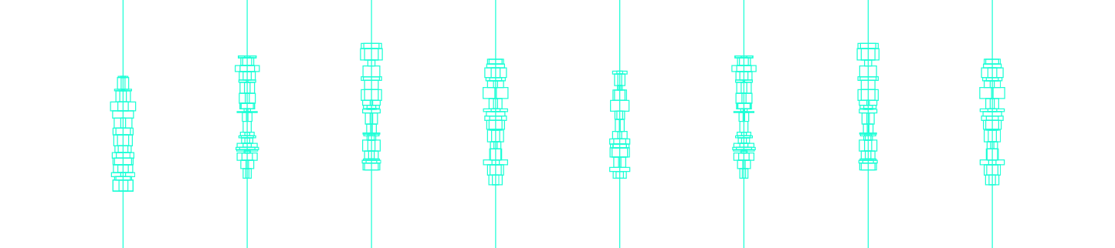

Figure 1: Lorem ipsum dolor sit amet, consectetuer adipiscing elit. Aliquam lacus nulla, pulvinar a, mattis ut, consequat sodales, elit.

Lorem ipsum dolor sit amet, consectetuer adipiscing elit. Aliquam lacus nulla, pulvinar a, mattis ut, consequat sodales, elit. Ut elementum justo ut urna. Pellentesque volutpat, urna et fermentum ultricies, massa erat mollis sapien, sed cursus justo felis rhoncus pede. Mauris tincidunt diam id nisl. Nulla aliquam, ante eget consequat suscipit, turpis est faucibus diam, gravida sollicitudin massa sapien id

Eksig_Heading2

Lorem ipsum dolor sit amet, consectetuer adipiscing elit. Aliquam lacus nulla, pulvinar a, mattis ut, consequat sodales, elit. Ut elementum justo ut urna. Pellentesque volutpat, urna et fermentum ultricies, massa erat mollis sapien, sed cursus justo felis rhoncus pede. Mauris tincidunt diam id nisl. Nulla aliquam, ante eget consequat suscipit, turpis est faucibus diam, gravida sollicitudin massa sapien id ipsum. Duis neque. rutrum tellus. Nullam ultricies purus ut dolor. Quisque arcu.

Eksig_Heading3

Lorem ipsum dolor sit amet, consectetuer adipiscing elit. Aliquam lacus nulla, pulvinar a, mattis ut, consequat sodales, elit. Ut elementum justo ut urna. Pellentesque volutpat, urna et fermentum ultricies, massa erat mollis sapien, sed cursus justo felis rhoncus pede. Mauris tincidunt diam id nisl. Nulla aliquam, ante eget consequat suscipit, turpis est faucibus diam, gravida sollicitudin massa sapien id ipsum. Duis neque. rutrum tellus. Nullam ultricies purus ut dolor. Quisque arcu.

Removing metadata from the paper

The double-blind review process requires that the paper is free of any information that could identify the author(s). Note that in addition to the text, the document’s *metadata* can also contain identifying information. For example, word documents automatically save author information based on the owner of the computer on which the file is edited and saved. Remove all metadata from the document file just prior to submission, using the following steps:

PC Windows (Word 2010, Word 2013)

* Within Word, while having the document open, click the File tab, and then click Info
* Click Check for Issues, and then click Inspect Document.
* In the Document Inspector dialog box, make sure the check box for Document properties and personal information is checked
* Click Inspect
* Click Remove All next to Document properties and personal information

Mac OS X (Word 2011)

1. In the **Word** menu, click **Preferences**.
2. Under **Personal Settings**, click **Security**.
3. Under **Privacy options**, select the **Remove personal information from this file on save** checkbox.
4. Save the document.

References (Heading 3 style) (one paragraph space after end of main text)

Adamson, G. (2007). Thinking through craft. Oxford, UK: Berg.

Bergström, J. et al. 2011. Becoming materials: material forms and forms of practice. Digital Creativity, 21(3), 155-172.

Giaccardi, E., Karana, E. (2015). Foundations of Materials Experience: An Approach for HCI. In Proceedings of CHI 2015. Seoul, South Korea. ACM Press: 2447-2456.

Holmquist, L. E. (2012). Grounded Innovation: Strategies for Creating Digital Products. San Francisco: Morgan Kaufman Publisher.

Karana, E., Pedgley, O., & Rognoli, V. (2014). Materials Experience: Fundamentals of Materials and Design. Butterworth-Heinemann: Elsevier, UK.

Nimkulrat, N. (2012). Hands-on intellect: integrating craft practice into design research. International Journal of Design, 6(3), 1-14.

Wiberg, M. et al. (2013). Materiality matters- experience materials. Interactions, 20(2), 54-57.

Zimmerman, J., Forlizzi, J., & Evenson, S. (2007). Research through design as a method for interaction design research in HCI. Proceedings of the 7th SIGCHI Conference on Human Factors in Computing Systems (CHI 2007). New York: ACM.

# Name of Author 1

Brief biography describing your experience, research and role, max 200 words in Normal Style.   
(**Leave the name and biography out of the review versions of the paper**)

Continue with any remaining authors